4/3/2018

Manually Building Expectation MaximizationAlgorithm in R

Machine Learning

Abbas Navsariwala

Deenadayalamuthu

Rohan Thorat

***Output chart for convergence:***

***We ran the EM algorithm for convergence threshold equal to 0.000001, 0.0001 and 0.01 for k = 2 to 10. And we came to a conclusion that with a 4 digit convergence threshold i.e. (0.0001) there are 9 clusters(k=9) with maximum iterations 20.***

***The converged log-likelihood value for 9 clusters is 140623.3978***

***Log-likelihood for each iteration are as follows***



***Summary of the Project***

The main objective of this project was to build an Expectation Maximization Algorithm manually using R.

The process to build the Expectation Maximization algorithm involved the following steps:

* Running K-means Algorithm
* Obtaining Initial Parameter values from the K-means Algorithm for the Initialization step in EM algorithm
* Executing the EM Algorithm

***About the Dataset and Cleaning the Dataset***

We are using cluster.csv dataset for our project. The size of the dataset is 1077 observations and 71 dimensions. Before executing the K-means algorithms we first cleaned the dataset. The dataset contained some NA values which were removed from the dataset by completely eliminating the row. The resulting clean dataset’s size is 1047 observations and 71 dimensions. Later on dimension ID was removed which resulted in 70 dimensions.

***Running K-means Algorithm***

After cleaning the dataset, we first initialized the number of clusters we want to start with in the K-means Algorithm. To begin with we started with k=2(in our case we defined it as n_clusters = 2). Then we ran the K-means with n_clusters = 2. We obtained the Cluster mean values for each cluster in each dimension. This is the basis for the EM algorithm.

***Obtaining Initial Parameter values from the K-means Algorithm for the Initialization step in EM algorithm***

To begin with the EM algorithm we need some initial values for the parameters which were obtained from the K-means Algorithm.

* μk (in our case we defined it as mu_initials)
* Covariance Σk  (in our case we defined it as sigma_initials)
* πk  (in our case we defined it as Pi_k_initials)
* Nk  (which is nothing but the total data points for k cluster)

Note: k stands for n_clusters

***Executing the EM Algorithm***

The Expectation-Maximization algorithm for Gaussian mixture is an iterative algorithm that starts from some initial parameter values and then proceeds to iteratively update either until convergence is detected or out of max iterations. Each iteration consists of an E-step and an M-step.

In our case convergence would be reached if log_likelihood is lower than the threshold value that is, in our case, 0.0001. Keeping the time constraint in mind we are iterating the model 20 times.

EM Algorithm has 4 steps:

1. Determining the Initial GMM Parameters (μk, Covariance Σk , πk , Nk )
2. Expectation Step
3. Maximization Step
4. Check for Convergence

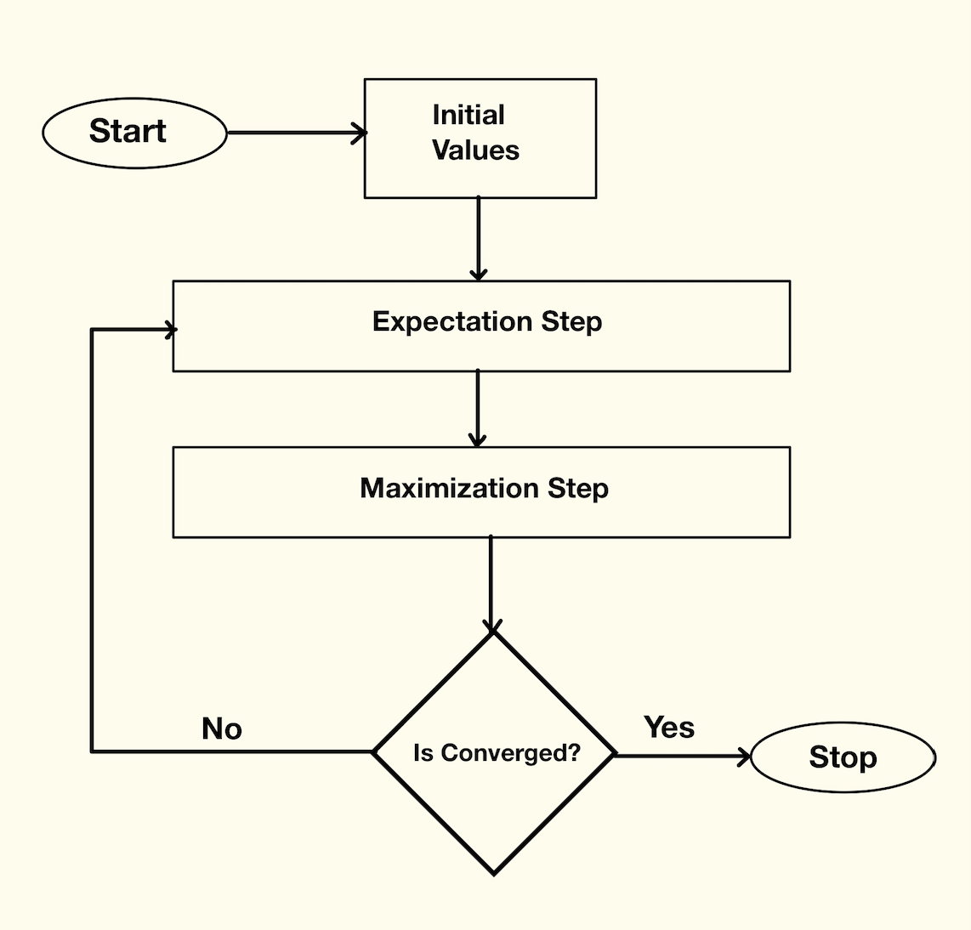

***Diving deep into the R Execution of the EM algorithm:***

# loading required libraries

library(dplyr)

library(mvtnorm)

# Getting the dataset into R

proj_data <- read.csv("~/cluster.csv", sep = ",", header = F)

# Exploring the dataset

head(proj_data)

dim(proj_data)

summary(proj_data)

# Removing the first column from the dataset

proj_data <- proj_data[-1]

# Checking for missing/NA values

sum(is.na(proj_data))

# Removing na values from the dataset

proj_data <- na.omit(proj_data)

dim(proj_data)

# Setting the number of clusters for K-means

n_clusters <- 9

# Getting the dimensions of the dataset

n_dimensions <- ncol(proj_data)

# K means clustering to get the initial parameters (mu_initial, sigma_initial)

cluster_pred <- kmeans(x = proj_data, centers = n_clusters)

# Getting initial mu values

mu_initials <- cluster_pred[2]

mu_initials <- mu_initials$centers

# Adding the cluster prediction to the dataset

proj_data_df <- data.frame(cbind(proj_data, cluster = cluster_pred$cluster))

# Getting the initial covariance array

sigma_initials <- array(rep(0),dim = c(n_dimensions, n_dimensions, n_clusters))

for (i in 1:n_clusters){

sigma_initials[,,i] <- cov(proj_data_df[proj_data_df$cluster == i, -71])

}

# Getting the initial Pi_k values

proj_data_df_by_cluster <- proj_data_df %>% group_by(cluster)

Pi_k_initials <- proj_data_df_by_cluster %>% summarise(size = n()) %>% mutate(Pi_k = size / sum(size))

Pi_k_initials <- Pi_k_initials$Pi_k

# Empty data structures for comp & responsibility

comp <- matrix(rep(0), nrow = nrow(proj_data), ncol = n_clusters)

responsibility <- matrix(rep(0), nrow = nrow(proj_data), ncol = n_clusters)

#dim(comp)

# _______________ Expectation Step _______________ #

# Defining expectation function

expectation <- function(x, mu_initials, sigma_initials, Pi_k_initials)

{

for (j in 1:n_clusters){

comp[,j] <- dmvnorm(x, as.matrix(mu_initials[j,]), as.matrix(sigma_initials[,,j])) * Pi_k_initials[j]

}

sum_of_comps <- rowSums(comp)

responsibility <- comp / sum_of_comps

ln_sum_of_comps <- log(sum_of_comps, base = exp(1))

sum_of_ln_sum_of_comps <- sum(ln_sum_of_comps)

list("log_likelihood" = sum_of_ln_sum_of_comps,

"responsibility_df" = responsibility)

}

# _______________ Maximisation Step _______________ #

# Creating empty data structures to store the values

Mu_new <- matrix(rep(0), nrow = n_clusters, ncol = n_dimensions)

N_k_new <- rep(0, n_clusters)

Pi_k_new <- rep(0, n_clusters)

sigma_t <- matrix(0, nrow = n_dimensions, ncol = n_dimensions)

sigma_t1 <- matrix(0, nrow = n_dimensions, ncol = n_dimensions)

Sigma_new <- array(rep(0),dim = c(n_dimensions, n_dimensions, n_clusters))

# Defining maximisation function

maximisation <- function(x, responsibility_df){

for (k in 1:n_clusters){

N_k_new[k] <- sum(responsibility_df[,k])

Pi_k_new[k] <- N_k_new[k] / nrow(x)

}

for (k in 1:n_clusters){

Mu_t <- ((1/N_k_new[k]) * (responsibility_df[,k] * x))

for (i in 1:n_dimensions){

Mu_new [k, i] <- sum(Mu_t[,i])

}

}

for (k in 1:n_clusters){

for (j in 1:nrow(x)){

difference_transposed <- t(x[j,] - Mu_new[k,])

difference <- x[j,] - Mu_new[k,]

co_efficients <- responsibility_df[j, k] / N_k_new[k]

sigma_t <- co_efficients * (difference_transposed %*% as.matrix(difference))

sigma_t1 <- sigma_t1 + sigma_t

}

Sigma_new[,,k] <- sigma_t1

}

list("Mu_new" = Mu_new,

"Sig_new" = Sigma_new,

"Pi_k_New" = Pi_k_new)

}

# _______________ Convergence Step _______________ #

for (i in 1:20){

if (i == 1){

# Initialization step

e_step <- expectation(proj_data, mu_initials, sigma_initials, Pi_k_initials)

m_step <- maximisation(proj_data, e_step[["responsibility_df"]])

current_log_likelihood <- e_step[["log_likelihood"]]

loglikelihood_vector <- e_step[["log_likelihood"]]

}

else{

# Repeatation for E and M steps until convergence

e_step <- expectation(proj_data, m_step[["Mu_new"]], m_step[["Sig_new"]], m_step[["Pi_k_New"]])

m_step <- maximisation(proj_data, e_step[["responsibility_df"]])

loglikelihood_vector <- c(loglikelihood_vector, e_step[["log_likelihood"]])

loglikelihood_diff <- abs((current_log_likelihood - e_step[["log_likelihood"]]))

# Check for Convergence

if(loglikelihood_diff < 0.0001){

break

}

else{

current_log_likelihood <- e_step[["log_likelihood"]]

}

}

}

**___________________________________________________________________**